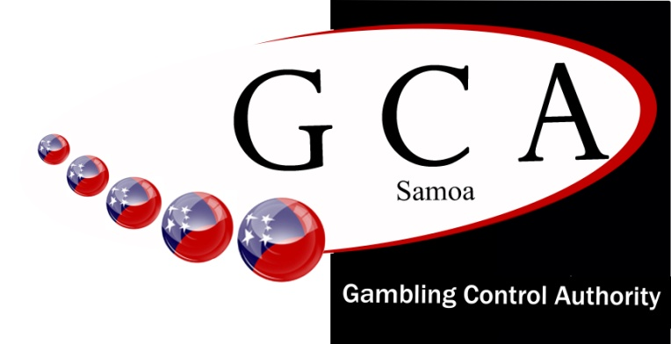
Gambling Control Authority
Phone: Upolu +685 26512/7790931
Phone: Savaii +685 56512/609087
Email: info@gca.gov.ws
Website: www.gca.gov.ws
PO Box 3705
Apia, SAMOA

GOVERNMENT OF SAMOA

Received by date | 17/09/2021
GCA Officer | Galumalemana
Receipt No & Amount
License Number
MOR License Number | 279324/93217

APPLICATION FOR BINGO SUPPLIES, WHOLESALER, RETAILER LICENSE

Name of Company: | MARIA NANSEN – SHOP MART
Address: | VAILOA
Telephone: | 7589633
Email:

Pursuant to Section 37 of the Gaming Control Act 2017

- Any person providing bingo supplies for the purpose of conducting a game of bingo must be licensed.

- In ensuring our functions under the act are carried out effectively, we wish to seek your cooperation on matters related to the sale of bingo products offered by your company.

- A person intending to provide bingo supplies must apply to the Chief Executive Officer for a licence permitting such sale or supply and the Chief Executive Officer has authority to grant or refuse the licence.
- The Chief Executive Officer has authority to impose such conditions applicable to a licence issued.

- The Chief Executive Officer has authority to revoke a licence issued for any reason and on any grounds.

- Any company supplying bingo supplies must have control systems in place to track cards imported into Samoa.

- A person who breaches the Act commits an offence and is liable upon conviction:

- in the case of a company, to a fine not exceeding 50 penalty units ($5000); or

- in any other case, to a fine not exceeding 20 penalty units ($2000).

- For the purpose of this section (37), “bingo supplies” are cards, papers and any other material or device
used for conducting the game of bingo.

At the time of filling this application for Retailers and Sales Promotion Scheme, a fee of $34.50 shall be paid. Upon approval a $345.00 annual fee must then be paid. A new license application and $379.50 fee shall be paid for each annual renewal of the license, for a wholesaler license a lodgment fee of $34.50 shall be paid, with $575.00 annual fee for each renewal of the license.

All records and control systems relating to the; import, sale of bingo supplies or equipment must be well kept and maintained. Records to include a complete and true description of the bingo supplies or equipment provided. Bingo Suppliers must make these records available to GCA Inspectors for auditing and verification purposes.

Bingo supplier personnel will not staff, promote or hold a financial interest in the conduct of a bingo game.

Applicant Signature _______________________

Date: ___________________________________

